**Design Documentation- Description, design of usage, interaction scenarios**

Use of appropriate techniques to demonstrate how your project would deliver on some of

the values identified in (1) for the identified users.

The benefits the app would bring to the university and students?



What will be included in the Design

* Sign in/up with university email
* Modules
* Active quizzes during lectures
* Daily quiz feature based on day’s lecture
* Unlockable when levelling up or with points
* Weekly leaderboard (later update)
* Staff quiz creation dashboard
* Staff/Student quiz results
* Badges (later update)
* Message platform between students and lecturers
* Settings
  + Profile
    - Avatar
    - Level / Points bar
    - Past quiz results
  + Change username
  + Change password
  + Log Out
  + Accessibility options
    - Audio Question Reader
    - Colorblind Level/Options (later update)
    - Light / Dark theme

Site Map

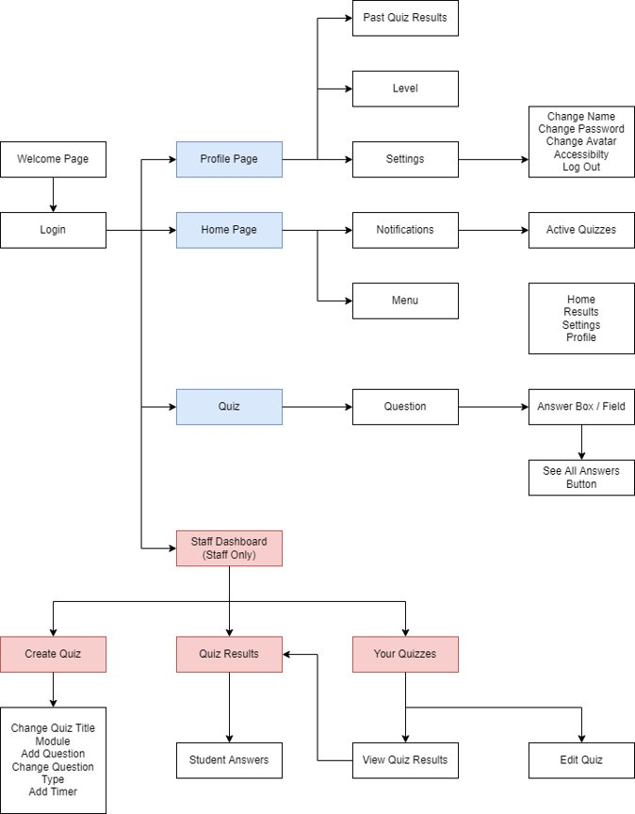

Flow of The App

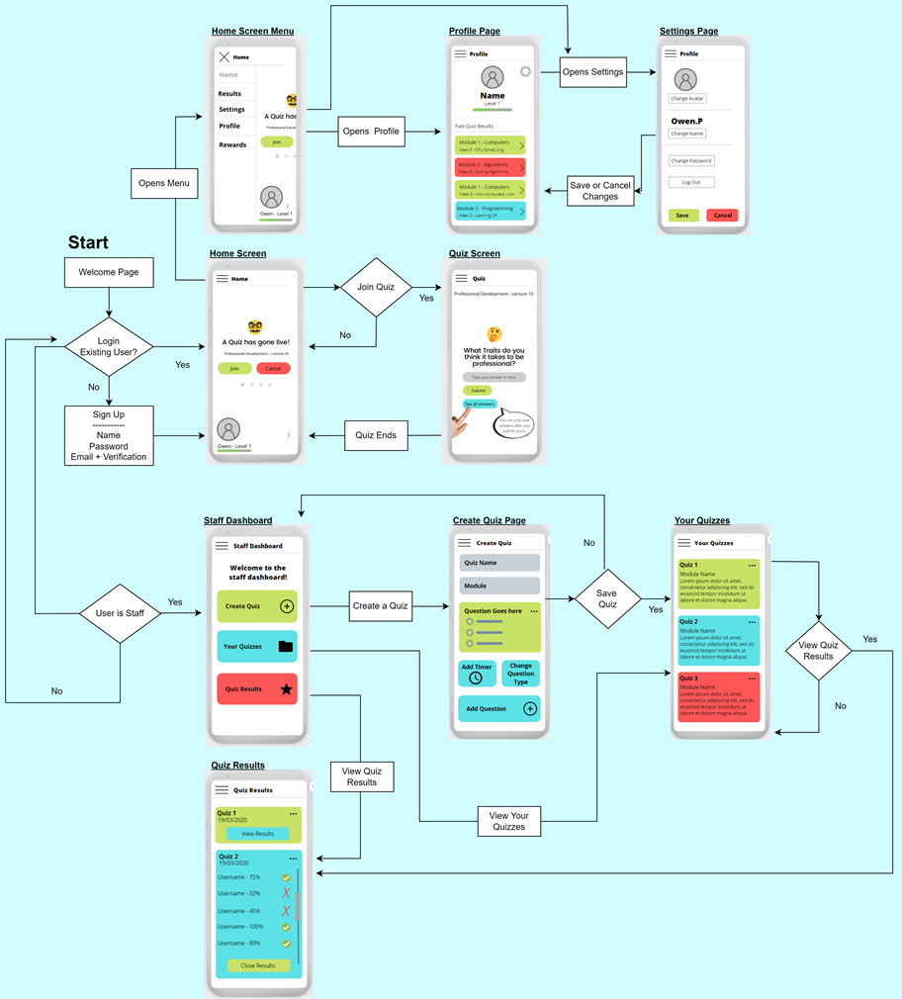

Settings Flow of Interaction

